 | Bansilal Ramnath Agarwal Charitable Trust’s Vishwakarma Institute of Information Technology  Department of  Artificial Intelligence and Data Science
Student Name: Sathe Onkar Abasaheb
Class: TY | Division: B |  | Roll No.: 372078
Semester: V |  | Academic Year: 2025-2026
Subject Name & Code: Cyber Security (AD31234B)
Assignment No: 06
Title of Assignment: Install and configure any web browser and explore various security settings at each OSI layer with small use cases.

Date of Performance: / /2025 |  | Date of Submission: / /2025

Objective
This assignment aims to systematically install, configure, and analyze web browser security mechanisms across all seven layers of the OSI (Open Systems Interconnection) model through practical implementation and comprehensive security assessment.

Materials Required
- Computer system with reliable internet connectivity
- Administrative privileges for software installation and system configuration
- Access to modern web browser applications (Chrome, Firefox, etc.)

Methodology and Technical Implementation

Web Browser Installation and Setup
- Select an appropriate web browser application (such as Google Chrome or Mozilla Fire- fox) for comprehensive security analysis and configuration.
- Perform a complete installation of the chosen browser following standard deployment procedures and manufacturer guidelines.

Comprehensive Security Analysis Across OSI Layers
- Launch the selected web browser and navigate to the configuration interface through the settings or preferences menu.

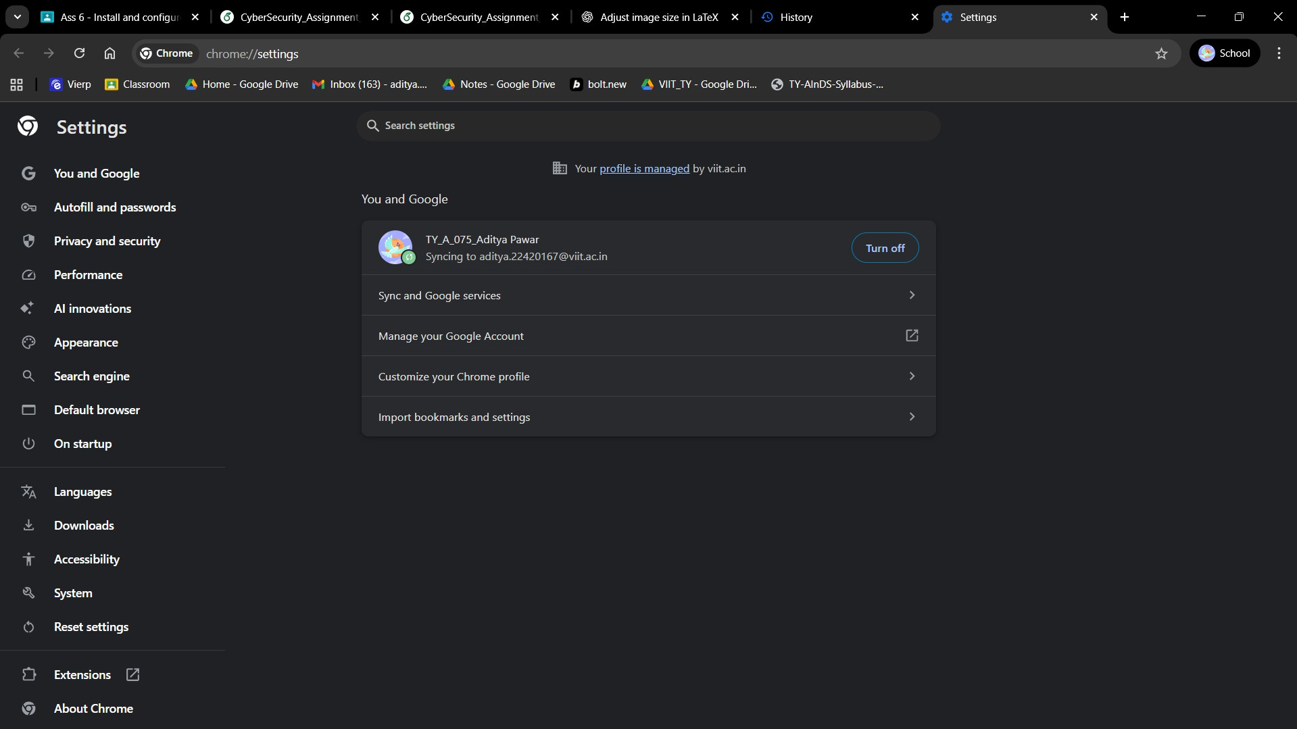
Figure 1: Google Chrome settings homepage.

- Conduct a systematic examination of security features available within the browser en- vironment, with particular emphasis on security controls corresponding to each layer of the OSI reference model (Physical, Data Link, Network, Transport, Session, Presenta- tion, Application).
Modern web browsers implement sophisticated security architectures that address po- tential vulnerabilities across multiple layers of the OSI model. While the majority of browser-centric security mechanisms operate primarily from the Data Link layer upward, this analysis examines how each layer contributes to comprehensive web security. The following sections detail the security controls implemented at each OSI layer and their specific roles in protecting web-based communications.

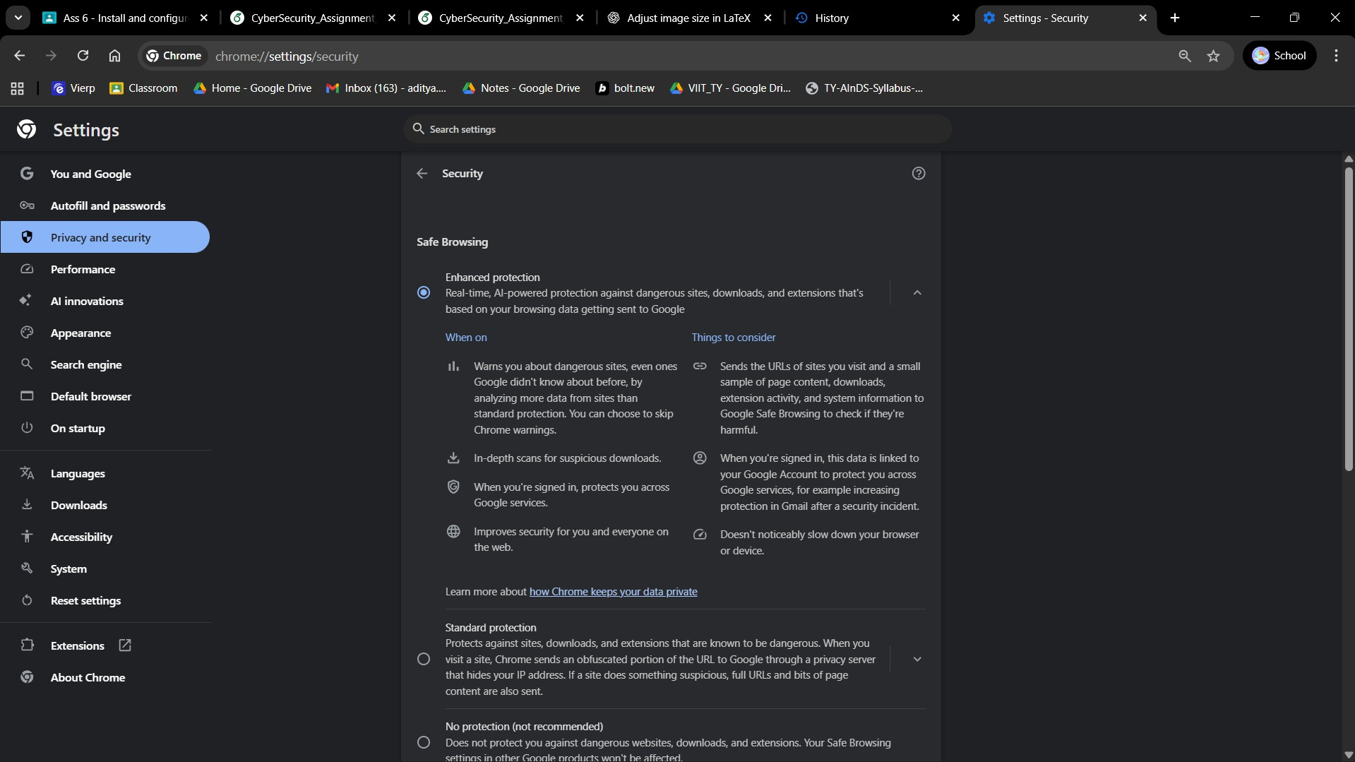
Figure 2: Chrome security settings page.

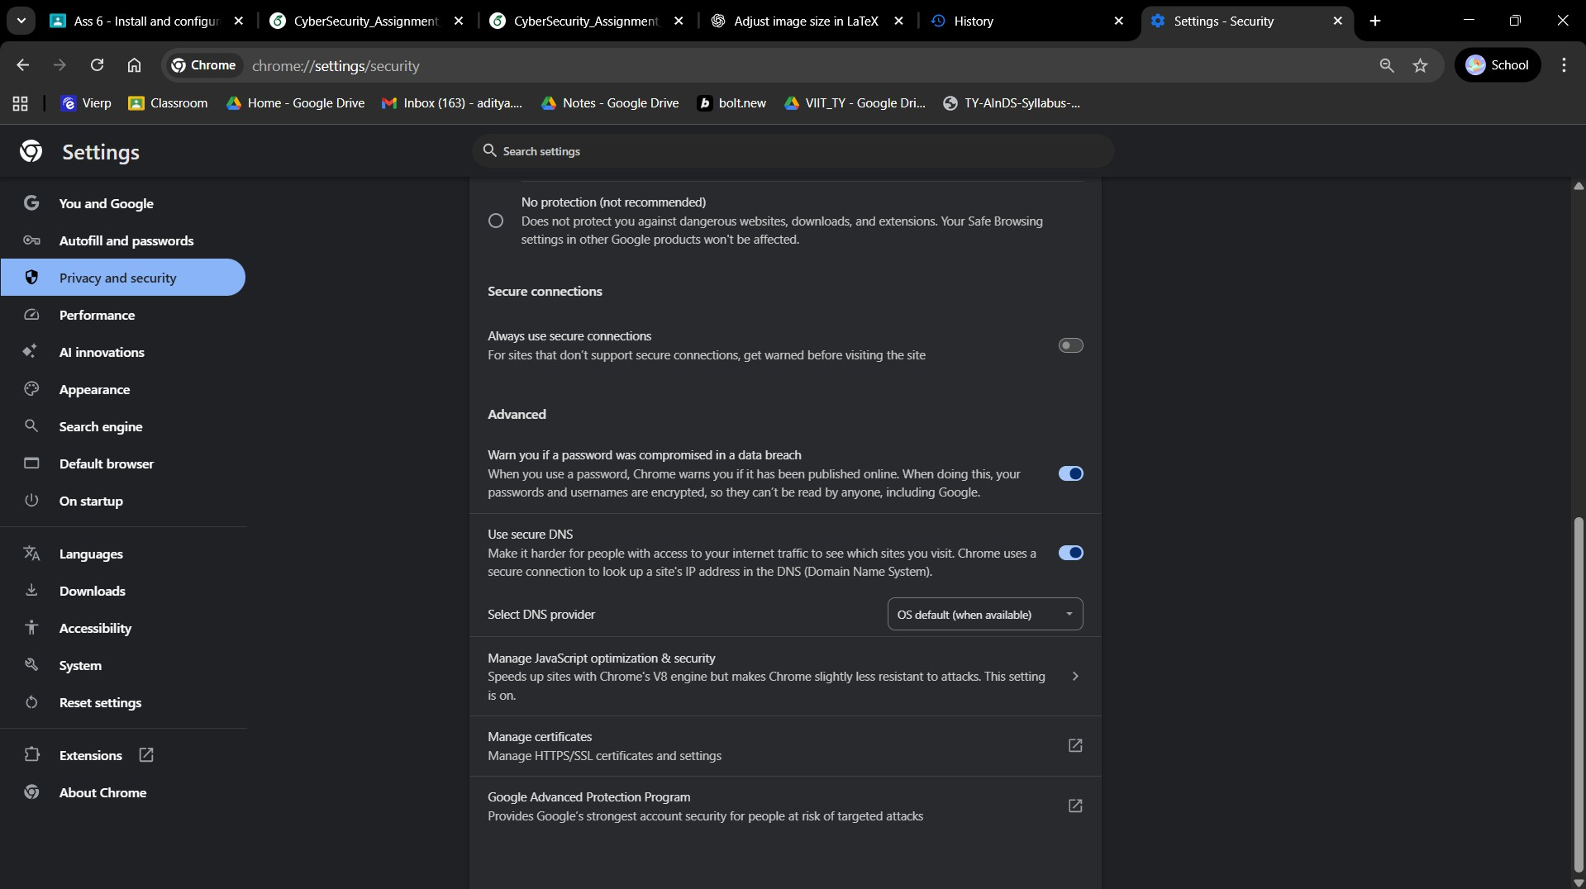
Figure 3: Chrome advanced security settings.

- Systematically analyze and document the security mechanisms implemented at each OSI layer, including their operational characteristics and protective functions.

Physical Layer Security Implementation
      - Security Mechanisms: Physical access restriction protocols, hardware-based se- curity deployment strategies, and environmental protection measures.
      - Functional Purpose: Establishes foundational protection against unauthorized phys- ical manipulation of network infrastructure components, including cables, routers, and computing devices. In the context of browser security, these measures provide indirect protection by securing the underlying hardware platforms through biomet- ric authentication, physical access controls, and environmental safeguards that pro- tect data transmission infrastructure.

Data Link Layer Security Protocols
      - Security Mechanisms: Media Access Control (MAC) address filtering, Address Resolution Protocol (ARP) spoofing prevention techniques, encryption protocols such as MACsec, and Point-to-Point Protocol (PPP) with Encryption Control Pro- tocol (ECP) implementation.
      - Functional Purpose: Ensures reliable and secure communication between adja- cent network nodes while preventing unauthorized network access and protecting data during transmission between network devices. Browser applications benefit from these protections as they mitigate man-in-the-middle attacks and frame ma- nipulation attempts at the local network level.

Network Layer Security Controls
      - Security Mechanisms: Comprehensive firewall rule implementation, Internet Pro- tocol Security (IPsec) protocols, and Virtual Private Network (VPN) configuration and management.
      - Functional Purpose: Manages packet routing security, authentication verification, and secure data delivery across network boundaries. These mechanisms encrypt browser communications at the Internet Protocol level, implementing access control policies that restrict network communication paths and mitigate risks associated with packet interception and routing-based attacks.

Transport Layer Security Architecture
      - Security Mechanisms: Transport Layer Security (TLS) and Secure Sockets Layer (SSL) protocol implementation, TCP/UDP port-based security controls, and transport- level firewall configurations.
      - Functional Purpose: Establishes end-to-end encrypted communication channels and maintains packet integrity throughout the transmission process. TLS config- uration within browser settings directly enables HTTPS functionality, providing authentication and confidentiality for web sessions while preventing eavesdropping and data tampering.

Session Layer Management Systems
      - Security Mechanisms: Advanced session management protocols, secure cookie implementation standards, session timeout policies, and multi-factor authentication (MFA) systems.
      - Functional Purpose: Coordinates the creation, maintenance, and secure termi- nation of communication sessions, providing protection against session hijacking attempts, replay attacks, and ensuring continuous authentication throughout the du- ration of browser sessions.

Presentation Layer Security Features
      - Security Mechanisms: Data encryption and decryption protocols (SSL/TLS), in- put validation systems, and data encoding preference controls.
      - Functional Purpose: Manages data formatting, translation, encryption, and com- pression processes. Browser applications utilize presentation layer security through SSL/TLS enforcement for encrypted data exchanges and real-time data translation protection to prevent attacks such as phishing and data manipulation.

Application Layer Security Implementation
      - Security Mechanisms: Popup blocking systems, anti-phishing technologies, anti- malware protection, secure protocol enforcement (HTTPS, SFTP), plugin and ex- tension management controls, automatic security updates, and content filtering ca- pabilities.
      - Functional Purpose: Provides comprehensive protection for end-user interactions and defends against application-specific attack vectors including Cross-Site Script- ing (XSS), Cross-Site Request Forgery (CSRF), and malware distribution. Appli- cation layer security serves as the primary defense mechanism for browser-based threats targeting users and web applications directly.
The implementation of security controls across all OSI layers creates a comprehensive defense architecture where each layer addresses specific threat categories, with particular emphasis on encryption, authentication, and user protection mechanisms in the upper layers.
- Develop practical scenarios and case studies to demonstrate the operational effectiveness and security impact of implemented security controls.

Physical Layer Security Case Study
Implementation Scenario: An enterprise organization implements comprehensive phys- ical security measures including secured server rooms with restricted access controls.
      - Security Impact: This implementation effectively prevents unauthorized personnel from gaining physical access to critical computing infrastructure, thereby mitigat- ing hardware-based attack vectors such as device tampering, unauthorized network monitoring equipment installation, and rogue wireless transmission device deploy- ment.

Data Link Layer Protection Analysis
Implementation Scenario: A corporate network deploys MACsec encryption protocols and implements MAC address filtering mechanisms on wireless access points.
      - Security Impact: These measures restrict network access exclusively to authorized devices, significantly reducing the risk of network spoofing attacks where malicious actors attempt to impersonate legitimate network hardware, consequently protecting browser communication sessions from local network-based intrusion attempts.

Network Layer Security Evaluation
Implementation Scenario: End users establish internet connectivity through Virtual Private Network (VPN) services with comprehensive encryption protocols.
      - Security Impact: Browser traffic is encrypted and routed through secure inter- mediary servers, effectively concealing user IP addresses and enhancing overall anonymity. Firewall systems actively filter suspicious IP packets, providing protec- tion against man-in-the-middle attacks and unauthorized data interception attempts.

Transport Layer Security Assessment
Implementation Scenario: Web browsers implement mandatory HTTPS protocol en- forcement utilizing Transport Layer Security (TLS) for all network connections.
      - Security Impact: All transmitted information, including authentication creden- tials and sensitive data, undergoes encryption before transmission. When malicious actors attempt to intercept communication between browser and server, they en- counter cryptographically protected data, providing effective defense against packet sniffing and denial-of-service attacks.

Session Layer Security Implementation
Implementation Scenario: Financial institutions enforce secure cookie policies and im- plement automatic session timeout mechanisms for inactive user sessions.
      - Security Impact: Session hijacking attack attempts are effectively neutralized as inactive or potentially compromised sessions are automatically invalidated within predetermined timeframes. Cookie encryption prevents unauthorized access to sen- sitive account information and maintains session integrity.

Presentation Layer Protection Mechanisms
Implementation Scenario: Browser applications implement content filtering systems that block downloads from suspicious sources and identify potentially dangerous MIME types.
      - Security Impact: These implementations provide effective protection against phish- ing attacks and malicious code injection attempts. Users receive appropriate warn- ings regarding potentially unsafe file formats, significantly reducing the probability of malware infection through disguised or manipulated content.

Application Layer Defense Strategies
Implementation Scenario: Comprehensive deployment of popup blocking mechanisms, anti-malware extensions, and automatic security update systems.
      - Security Impact: Users receive comprehensive protection from phishing popup windows, drive-by download attacks, cross-site scripting (XSS) vulnerabilities, and security exploits targeting outdated browser components. Malicious plugin exe- cution is prevented, significantly reducing the attack surface available to threats targeting end users directly.

Practical Configuration and Implementation Analysis
- Identify and select representative security mechanisms from each OSI layer for detailed configuration analysis.
- Implement security configurations according to established industry best practices and recommended security standards.
- Systematically document the complete configuration procedures and implementation method- ologies.

Application Layer Configuration: Permission-Based Access Control (Camera & Microphone)
Security Rationale: Implements granular access control to prevent unauthorized activation of audio/video recording devices and maintains user privacy protection.
Recommended Implementation: Configure Camera and Microphone permissions to require explicit user authorization and systematically remove previously granted permissions for un- trusted applications.

Configuration Methodology (Chrome Browser):
- Launch Chrome browser application.
- Access browser configuration through the main menu → Settings interface.
- Navigate to Privacy and Security → Site Settings configuration panel.
- Configure Camera permissions → ensure Ask before accessing policy is activated.
- Return to Site Settings → configure Microphone permissions → verify Ask before ac- cessing policy is enabled.
- Audit and remove unauthorized sites from the Allowed permissions list using the site management interface → Remove function.
Implementation Consideration: This configuration will generate permission request dialogs for legitimate video communication applications, which represents normal security behavior.
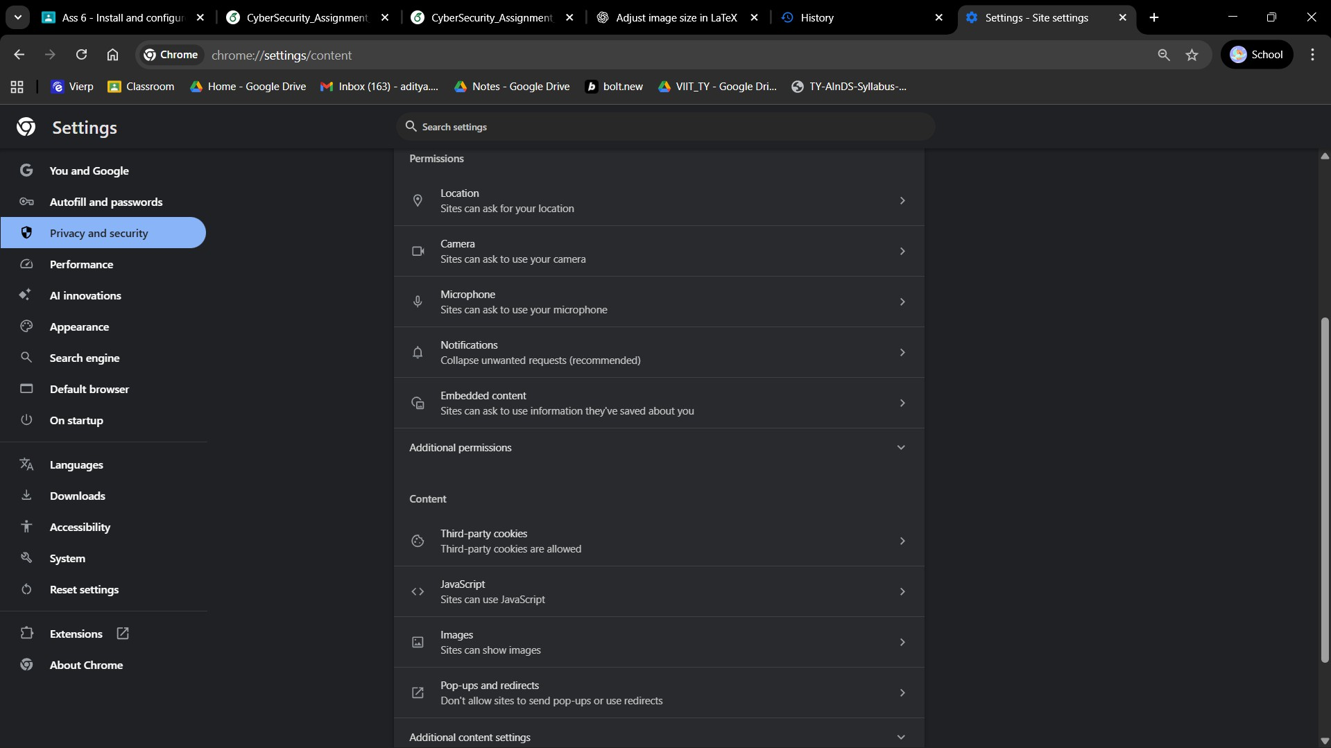
Figure 4: Site permissions settings.

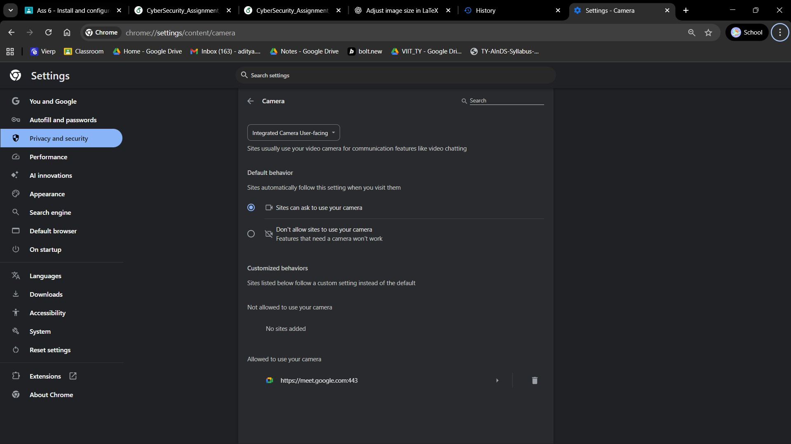
Figure 5: Camera access settings.

Presentation Layer Configuration: Certificate Management and Validation
Security Rationale: Transport Layer Security (TLS) certificates provide essential encryption and server identity verification for the presentation layer security framework.
Recommended Implementation: Implement systematic certificate validation procedures and maintain certificate authority trust store integrity.

Configuration Methodology (Chrome Browser):
- Navigate to Settings → Privacy and Security → Security configuration panel.
- Access Advanced settings → select Manage certificates to open the operating system certificate management interface.
- For individual site certificate inspection: access target website → select padlock icon in address bar → Connection is secure → Certificate is valid → review certificate issuer and validity period.
Implementation Consideration: Removal of legitimate Certificate Authorities will disrupt HTTPS connectivity to dependent websites requiring careful evaluation before modification.

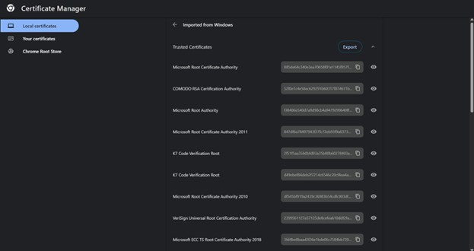
Figure 6: Certificate Manager.

Session Layer Configuration: Cookie Management and Session Data Control
Security Rationale: Session cookies and third-party tracking mechanisms present significant privacy and security risks through cross-site tracking capabilities and potential session hijack- ing vulnerabilities.
Recommended Implementation: Implement comprehensive third-party cookie blocking and establish automatic session data clearing protocols.

Configuration Methodology (Chrome Browser):
- Navigate to Settings → Privacy and Security → Cookies and other site data.
- Configure cookie policy by selecting Block third-party cookies.
- For enhanced privacy protection, activate Clear cookies and site data when you quit Chrome.
- Utilize See all cookies and site data interface to selectively remove specific website cook- ies and stored data.
Implementation Impact: Third-party cookie blocking may disrupt certain authentication flows, payment processing systems, and embedded content functionality, requiring site-specific ex- ceptions for essential services.

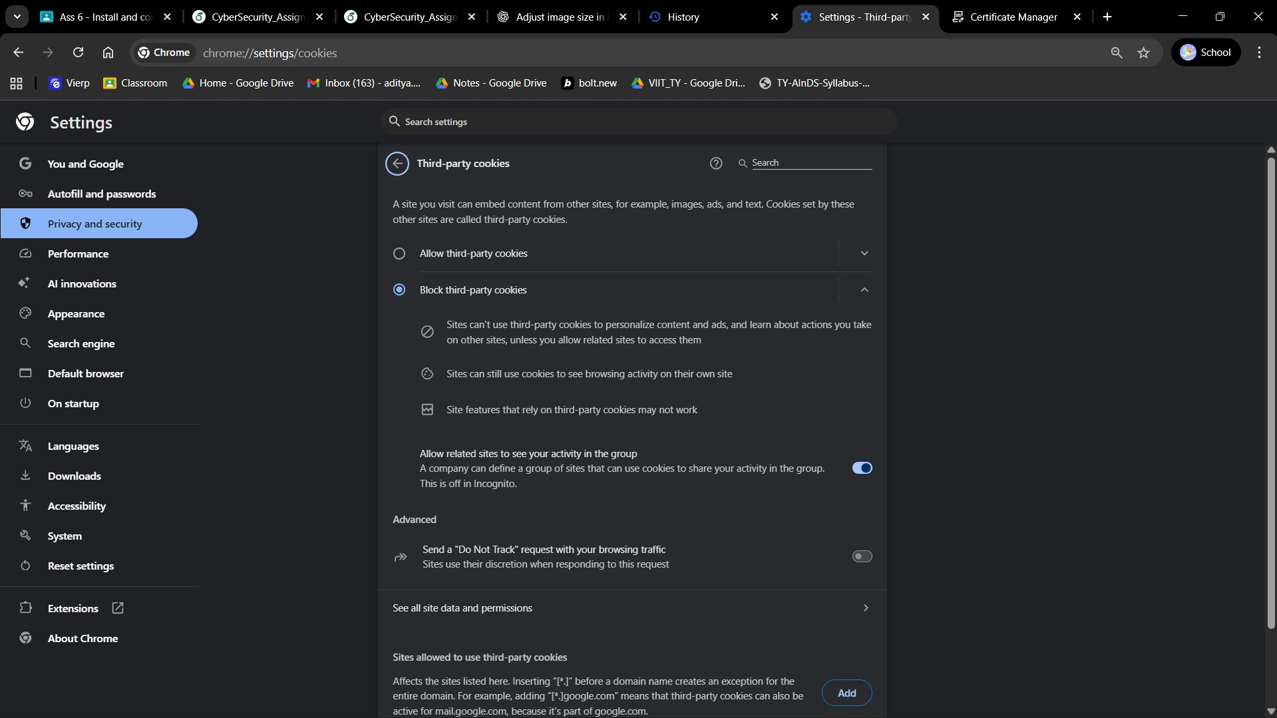
Figure 7: Cookie settings.

Transport Layer Configuration: HTTPS-Only Mode Implementation
Security Rationale: Enforces encrypted communication channels and prevents unintentional transmission of sensitive data through insecure HTTP connections.
Recommended Implementation: Enable HTTPS-Only mode with secure connection upgrades and implement fallback protection mechanisms.

Configuration Methodology (Chrome Browser):
- Access Chrome Settings through the main menu → Settings interface.
- Navigate to Privacy and Security configuration section.
- Select Security settings panel.
- Locate Transport Security Configuration → activate Always use secure connections.
- Configure DNS over HTTPS by enabling Use secure DNS and selecting an appropriate secure DNS provider.
Implementation Impact: Some legacy websites may become inaccessible due to lack of HTTPS support, requiring alternative access methods or manual security exceptions.

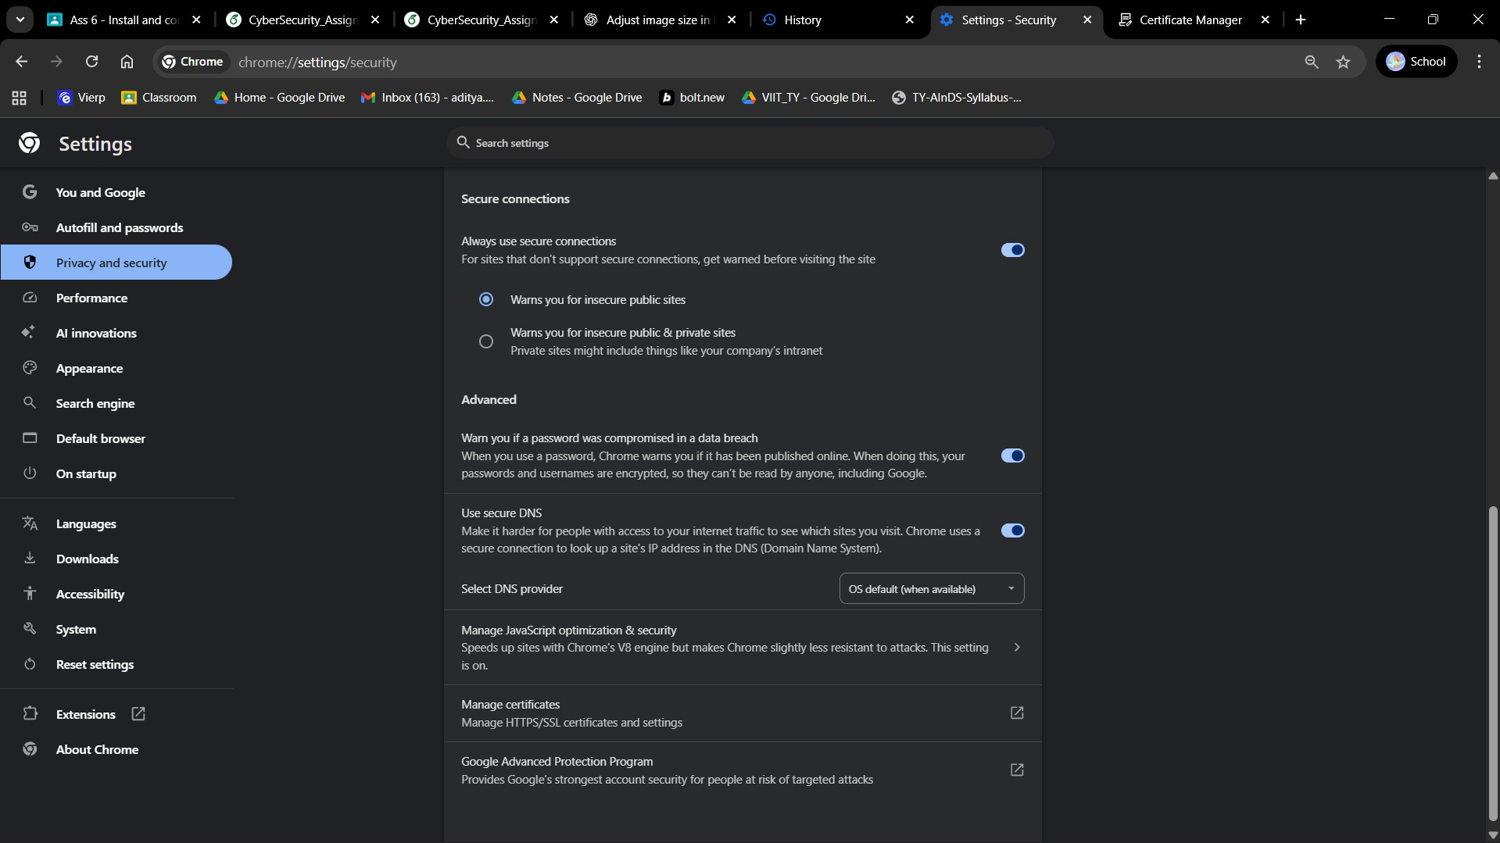
Figure 8: Secure DNS settings.

Network Layer Configuration: Proxy and System Network Security Management
Security Rationale: Network layer routing configuration and proxy management determine traffic handling methodologies and represent critical attack vectors for malicious traffic redi- rection.
Recommended Implementation: Establish secure proxy configuration protocols and disable automatic proxy detection mechanisms to prevent unauthorized traffic manipulation.

Configuration Methodology (Chrome Browser on Windows):
- In Chrome browser: navigate to Settings → System → select Open your computer’s proxy settings.
- Access Windows Settings → Network & Internet → Proxy configuration panel.
- Disable automatic proxy detection by deactivating Automatically detect settings option.
- Verify manual proxy configurations for accuracy and security compliance.
Implementation Impact: Incorrect proxy configuration may result in complete loss of web connectivity requiring careful validation of network settings.

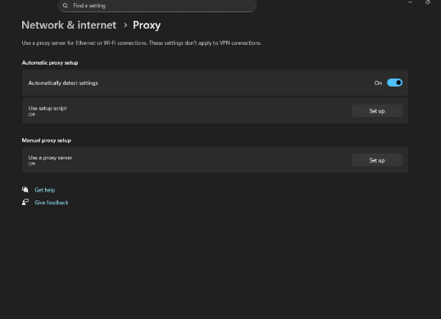
Figure 9: Windows Proxy Settings.

Layer 2 - Data Link: Prevent WebRTC IP leaks
    - Data Link Layer Configuration: WebRTC Network Leak Prevention
Security Rationale: Web Real-Time Communication (WebRTC) protocols may inadvertently expose local and public IP address information, potentially circumventing proxy server and Virtual Private Network (VPN) anonymization efforts.
Recommended Implementation: Deploy specialized WebRTC control extensions to prevent unauthorized IP address disclosure and maintain network anonymity.

Configuration Methodology (Chrome Browser):
- Access the Chrome Web Store through browser navigation.
- Search for and install the WebRTC Network Limiter security extension.
- Following successful installation, activate the extension through the browser toolbar in- terface.
- Verify configuration effectiveness using WebRTC leak testing services at https://browserleaks. com/webrtc.
Implementation Impact: WebRTC functionality restrictions may affect browser-based video communication applications requiring selective enabling for trusted applications.

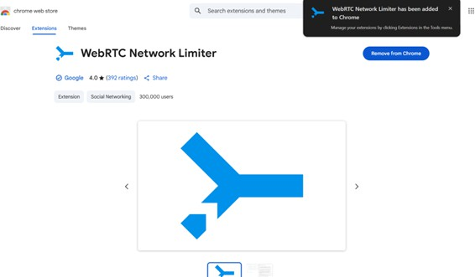
Figure 10: WebRTC Network Limiter Extension in Chrome Web Store.

Physical Layer Configuration: Hardware Security Key Implementation
Security Rationale: Hardware security keys provide cryptographic authentication mechanisms that are inherently resistant to phishing attacks and social engineering attempts.
Recommended Implementation: Integrate hardware security keys as secondary authentica- tion factors for high-value accounts and enable comprehensive two-step verification protocols.

Configuration Methodology (Google Account):
- Navigate to myaccount.google.com → Security configuration panel.
- Select 2-Step Verification settings → follow guided prompts to Add security key.
- Insert the physical hardware security key when prompted for device registration.
- Complete verification process to establish secure authentication relationship.
Implementation Consideration: Physical hardware key requirements mandate secure storage and backup key provisioning to prevent account lockout scenarios.

Security Implementation Demonstration and Practical Anal- ysis

Application Layer Security Demonstration: Site Permission Controls
Scenario Analysis: When a potentially malicious website attempts to access device camera or microphone resources, the implemented permission control system generates an explicit
authorization request dialog, enabling users to deny unauthorized access attempts and maintain device privacy.

Presentation Layer Security Demonstration: TLS Certificate Valida- tion
Scenario Analysis: In cases where phishing attacks redirect users to fraudulent banking web- sites, systematic certificate inspection reveals certificate issuance to unauthorized domains rather than legitimate banking institutions, enabling users to identify and avoid credential com- promise attempts.

Session Layer Security Demonstration: Third-Party Cookie Blocking
Scenario Analysis: Implementation of third-party cookie blocking mechanisms effectively prevents advertising networks from constructing comprehensive user behavior profiles across multiple websites, significantly enhancing user privacy and reducing cross-site tracking capa- bilities.

Transport Layer Security Demonstration: HTTPS Enforcement and Secure DNS
Scenario Analysis: Automatic HTTP-to-HTTPS protocol upgrade functionality ensures data encryption during transmission. Concurrent implementation of DNS over HTTPS prevents Internet Service Providers from monitoring domain resolution activities, providing compre- hensive transport layer protection.

Network Layer Security Demonstration: Proxy Configuration Man- agement
Scenario Analysis: Disabling automatic proxy detection mechanisms prevents browser ap- plications from connecting to potentially malicious proxy servers deployed on public wireless networks, maintaining secure direct connectivity and preventing traffic interception.

Data Link Layer Security Demonstration: WebRTC Leak Prevention
Scenario Analysis: Specialized browser extensions prevent websites from discovering ac- tual IP addresses when users employ Virtual Private Network (VPN) services, maintaining anonymization integrity and preventing location disclosure through WebRTC protocols.

Physical Layer Security Demonstration: Hardware Security Key Au- thentication
Scenario Analysis: Even in situations where phishing attacks successfully compromise user passwords, hardware security key requirements prevent unauthorized account access since ma- licious websites cannot replicate the cryptographic response generated by physical security devices configured for legitimate domain authentication.

Conclusion
This comprehensive analysis and systematic implementation of web browser security config- urations across all seven layers of the OSI model demonstrates the effectiveness of layered security architecture in enhancing overall web browsing safety and privacy protection. The practical implementation reveals that each OSI layer contributes distinct security capabilities that collectively provide comprehensive protection against diverse threat vectors.
At the Application layer, implementation of permission-based access controls for camera and microphone resources establishes effective prevention mechanisms against unauthorized multimedia data capture. The Presentation layer analysis emphasized the critical importance of systematic website certificate validation procedures in ensuring server authenticity and pre- venting sophisticated phishing attack vectors. Session layer security implementation through comprehensive third-party cookie blocking significantly reduces cross-site tracking capabilities while protecting user session integrity.
Transport layer security enhancement through mandatory HTTPS protocol enforcement and DNS over HTTPS implementation ensures comprehensive data encryption during transmission and secure domain name resolution processes. Network layer configuration adjustments, partic- ularly proxy setting management, effectively minimize security risks associated with malicious traffic intermediaries. Data Link layer WebRTC leak prevention mechanisms successfully safe- guard IP address privacy and maintain network anonymization integrity. Physical layer security enhancement through hardware security key integration introduces robust secondary authenti- cation factors that demonstrate superior resistance to phishing and social engineering attacks.
The systematic implementation of these multi-layered security configurations demonstrates that adopting comprehensive best practices across each OSI layer creates a synergistic security framework that significantly fortifies web browser applications against diverse security threats. This layered approach ensures enhanced user safety, improved privacy protection, and more secure web browsing experiences through systematic defense-in-depth implementation strate- gies.

References
- Google Chrome Security Settings Documentation. (2025). Retrieved from
https://support.google.com/chrome/answer/114836
- Mozilla Firefox Security Guide. (2025). Retrieved from
https://support.mozilla.org/en-US/kb/security
- OWASP Browser Security Guide. (2025). Retrieved from
https://owasp.org/www-project-web-security-testing-guide/

